# Structure

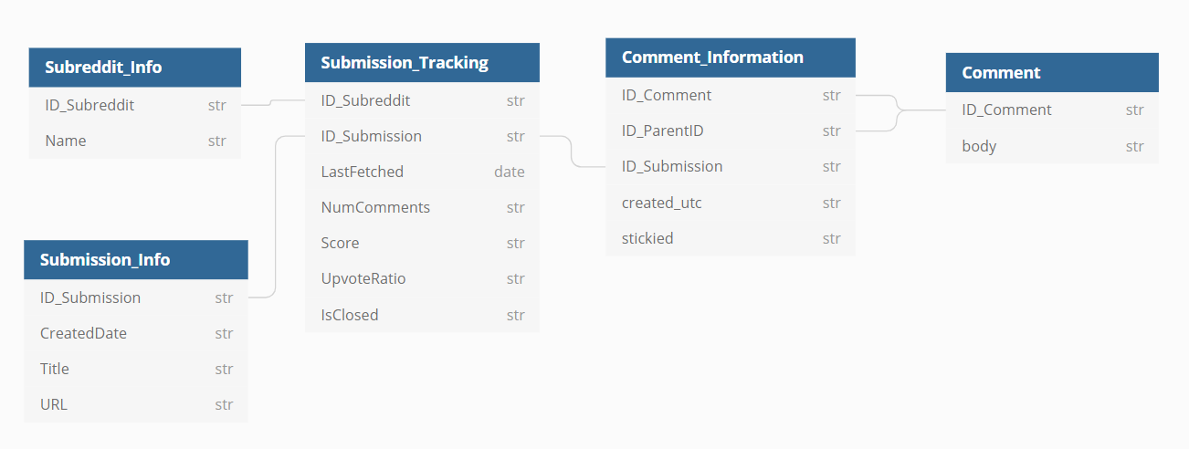

# Data Dictionary

## Submission_Tracking

## Subreddit_Info

## Submission_Info